Main Agenda- To perform the CRUD operations

For this we need a local database with properties and records in it

And after this we need the local database with the details I created the customer and under it forur properties

And now in here I want to create update delete and clear the records

For that I need a flow and flow acion and a section so let’s create them

And then create a section with the fields in the database and create text inputs

And for these all the fields give post value so that can see in the clipboard and the value of so give the action set as

And for all the fields configure as same

And after this we need buttons to perform the operations

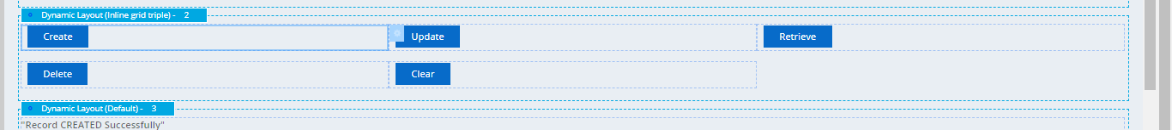

Create buttons with it

And to perform these actions we need the data transform and activity

First let’s go with the data transform

And give the clipboard and give the parameter as your text property where I created as operation as which operation to perform and next we would give this in the parameters

And now let’s configure the Activity now In which we are using the basic operations such as

Obj-Save- for saving the record to the database and we can use the write now option to see immediate results in the database

And we can give the when condition as create operation is performed

And need to specify the

And in the 2 nd step also we are using the same obj-save to update the record and to do this also we are using same write-now but changing the when conditions as to perform this step while doing the update

And in the 3rd step we are using Obj-Open to get the record from the database basically using for the retrieve thing and in here we need to specify the class of the database

And in here we use the lock and commit to use it for the delete operation where in we can first retrieve the record and we can use it for delete since we are dealing with database so that only record we can use it for that only record and other records won’t get disturbed

And in the open we can give the property on which basis it should be opened so I am giving here as the CustID and value we can take from the clipboard pyWorkPage and when it comes on the page automatically we can see in the database and next is delete operation for this we can use the obj-delete action and we can select remove and in the step page we can get the values in the single page property we need to store the instances and then delete the instances

And in here we have the clear option also so that the records could get cleared and then use the Page-Remove and give the single page property created under it and give the page under the step page of the activity

Now after creating all these things DT and activity we need to pass these things for the buttons which we created earlier to work on

Starting with the create button

And same follows for all button the operation performed changes

Update button

Retrieve button

Delete button

Clear button

Under all these action sets can pass the DT and our activity under this

Before performing we have only one record inn the database

Now let us create one record

Now after entering the new details in case

Now let’s check in clipboard

Values are shoen in clipboard under pyWorkPage now let’s check the database

And these got created

Now lets update the records first we will create record and then update

Now after creation

We have these records

And let’s update the records and check in the clipboard

After updating the name from datta to Gopi we have

Name changed under the same thing

And let’s check in the DB

Now with the same ID the name got updated now let’s retrieve a record with the help of custID

Before this I entered only Cust ID

Now after the retrieve is clicked then we have the records populated

And now let’s delete the records and when we are deleting the recids first we need to retrieve the record and then delete

Fiest retrieved the record and let’s go for the delete now

And when pressed deleted we would delete it let’s check in the DB

Now we have only two records

So the row got deleted

Now let’s do for the clear button now after the retrieval we would get the records and could see in the clipboard

After pressing the clear button we have the

Nothing would be on the UI screen and in the clipboard also no values

So we performed all the operations